**Project Title:**

**Network Design proposal for Internet Café**

**Abstract:**

Network design for Internet café to support 30 users and also ensure web filtering and ADSL internet connection.

**Primary methods used:**

* Formulating a proper plan.
* Designing complete network diagram in Cisco Packet Tracer.
* Creating logical and physical links between all the components.
* Ensuring web filtering, message and packet switching
* Ensuring that nodes and links are arranged appropriately using proper network topology.

The major results of our project will be PCs being able to share and access files among each other, Users will be able to login to the main server via login credentials and serve their purposes accordingly, Message passing will also be ensured. IP addresses and connections will be appropriate based on the requirements and LAN topology. Web filtering and a proper billing method will also be implemented.

The final project will ensure a proper network design implemented for an Internet café supporting around 30 users at a time. All day-to-day activities can be successfully performed by the users at a given time. This project will ensure a proper full time running internet cafe.

It will also ensure a secure inter connection from the ISP, a router with high-speed internet connection, firewall capabilities to incorporate web filtering, one or more switches to link to one another over an internal network.

**Project Objective:**

The project is to prepare a network design proposal for an Internet cafe. The following are the requirements. The cafe is to support 30 users and requires a web filtering device or software to filter websites based on content. The users need to share one ADSL internet connection. The cafe has to be managed with a billing software.

There are many objectives that we need to achieve to accomplish this project. The objective of each process varies based on the course outcome that were asked by question. The objectives are: -

* To learn how to setup a simple network using the simulation tools which is the Packet Tracer.
* To share files between PC in the packet tracer using command prompt.
* To check a connection between devices in a network using command prompt.
* To check the IP address of devices that are connected to our network using command prompt.
* To view a list of station that are connected in a network using command prompt.
* To send message between devices in the network.
* To provide a network monitoring tool that is available to monitor our network.
* To connect 3 printers, one to each router, so that one printer will be shared among 10 PCs.
* To ensure web filtering through firewall protection and manage a proper billing software.

**Modules of the Project:**

1. **Network Design Requirement:** Designing large-scale networks to meet today’s dynamic business and IT needs and trends is a complex assignment, whether it is an enterprise or service provider type of network. This is especially true when the network was designed for technologies and requirements relevant years ago and the business decides to adopt new IT technologies to facilitate the achievement of its goals but the business’s existing network was not designed to address these new technologies’ requirements.

There are two common approaches to analyze and design networks:

* **The top-down approach:** The top-down approach simplifies the design process by splitting the design tasks to make it more focused on the design scope and performed in a more controlled manner, which can ultimately help network

designers to view network design solutions from a business- driven approach.

* **The bottom-up approach:** In contrast, the bottom-up approach focuses on selecting network technologies and design models first. This can impose a high potential for design failures, because the network will not meet the business or applications’ requirements.

To achieve a successful strategic design, there must be

additional emphasis on a business-driven approach.

This implies a primary focus on business goals and

technical objectives, in addition to existing and future

services and applications.

**2) Design Requirements Analysis:** Requirement analysis encompasses those tasks that go into. determining the needs or conditions to meet for a new or altered product or project, taking account of the possibility. Conflicting requirements of the various stakeholders, analysing, documenting, validating and managing software or systems. Software requirements break-down the steps needed to meet the business requirement or requirements.

**3) Network Diagram:** A computer network diagram is a schematic depicting the nodes and connections amongst nodes in a computer network or, more generally, any telecommunications network. Computer network diagrams form an important part of network documentation. The physical network topology can be directly represented in a network diagram, as it is simply the physical graph represented by the diagrams, with network nodes as vertices and connections as undirected or directed edges (depending on the type of connection). The logical network topology can be inferred from the network diagram if details of the network protocols in use are also given.

**4) IP Address Design:**  An IP address allows computers to send and receive data over the internet. Most IP addresses are purely numerical, but as internet usage grows, letters have been added to some addresses. There are four different types of IP addresses: public, private, static, and dynamic. While the public and private are indicative of the location of the network private being used inside a network while the public is used outside of a network static and dynamic indicate permanency.

**5) Hardware and Software Products:**

**ADSL ROUTER:** Asymmetric digital subscriber line (ADSL) is a type of digital subscriber line (DSL) technology, a data communications technology that enables faster data transmission over copper telephone lines than a conventional voiceband modem can provide.

**SWITCH:** A network switch is networking hardware that connects devices on a computer network by using packet switching to receive and forward data to the destination device. A network switch is a multiport network bridge that uses MAC addresses to forward data at the data link layer of the OSI model.

**COMPUTERS:** In telecommunications networks, a node is either a redistribution point or a communication endpoint. The definition of a node depends on the network and protocol layer referred to. A physical network node is an electronic device that is attached to a network, and is capable of creating, receiving, or transmitting information over a communication channel. This is also known as a personal computer.

**OPERATING SYSTEMS LICENSE:**

Operating systems such as windows, if paid for, provide updates which you can make use of and which can be essential for the smooth running of your OS.

Licensed systems are genuine and it does not provide any virus attacks.

It is the Authorized Version of any Software,

It is Trustworthy & More Secure,

It has all Legal Usage of any Features without Restrictions.

**ANTIVIRUS:**

Antivirus software, also known as anti-malware, is a computer program used to prevent, detect, and remove malware. Antivirus software was originally developed to detect and remove computer viruses, hence the name.

**Each module description of the project:**

**1) Network Design Requirement:** To design a network for an internet cafe which has 30 users. The internet cafe has one

ADSL connection which is to be shared among the users. A

cafe billing management system has to be configured and

deployed in the cafe.

**2)Design Requirements Analysis:** The internet cafe is to support 30 users. So, 30 desktop computers would be required. To form a network for the computers, a switch would be required. Since 30 computers need to be networked, a switch with 30 ports would be required. Switches typically come with 24 ports or 48 ports. Since a 24-port switch would not suffice the requirement, a 48-port switch is recommended.

An ADSL router which is capable of NAT (Network address translation) is required. NAT is a mandatory feature which is required on the router, for sharing the ADSL internet connection.

The router, although not mandatory, needs to have the DHCP server feature installed. The DHCP server is required for providing dynamic IP addresses to the users. The availability of the feature on the router reduces rules out the need to setup and configure an additional DHCP server on the network.

As the users in the cafe need to be managed with a billing system, additional software has to be installed and configured on the appropriate operating system for which it is supported.

**3) Network Diagram:**

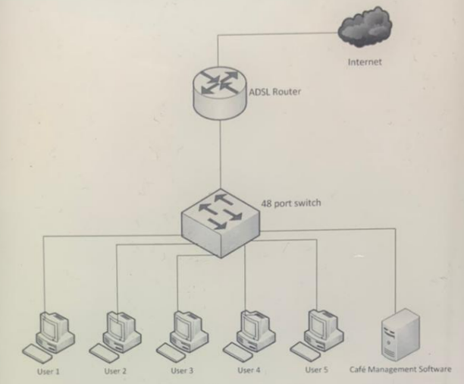

* The components corresponding to the users connect to the ports on the switch. In the diagram, only 5 users are shown.
* The switch is a 48-port switch. The computers connect to the switch using Ethernet RJ45 cables.
* The cafe management software is installed on the appropriate operating system and set up on the network.
* The ADSL router is deployed as shown in the diagram. The router has two interfaces. The WAN interface of the router is connected to the internet and the LAN interface is switched.
* The ADSL router is configured for NAT. When the feature is enabled, internal users would be able to share the internet IP address which would be available on the WAN interface of the router.
* The DHCP feature on the router would provide appropriate IP address, subnet mask, default gateway and DNS server IP addresses for the user’s computers.

**4) IP Address Design:**

* The interval private IP address range for the users within the cafe is 192.168.1.0/24.
* The DHCP scope on the router should lease out IP addresses on the 192.168.1.0/24 scope.
* The IP addresses of the LAN interface of the router and the computer on which the cafe management system is setup should be configured with a static IP address belonging to the 192.168.1.0/24 network.
* It should be ensured that the static IP addresses provided for the LAN interface of the router and the cafe management system are excluded from the DHCP scope configured on the router for avoiding duplicate IP addressing.
* The DHCP scope should be configured with appropriate default gateway and DNS server addresses to be leased out to the clients.
* The default gateway and the DNS server which is to be provided in the DHCP scope would be the IP address of the LAN interface on the router.

**5) Hardware and Software Products:**

**ITEMS:**

* ADSL Router
* Switch
* Computers
* Operating systems license
* Antivirus
* Cafe management

**Product Quantity:**

* Netgear DG834 or 1

ZyXEL prestige

660R-D1 or D-Link

DSL-2540B

* NETGEAR ProSafe 1

GS748T or D-Link

DES 1210 Switch or

Cisco Catalyst

2960S-48TD-L

HP/IBM/Custom 30

assembly

Windows 7/ XP 30

* Windows antivirus 30 solution or Norton or Mcafee

Cafesuite,Cafezee,1 handycafe

**Screenshot of the Project:**

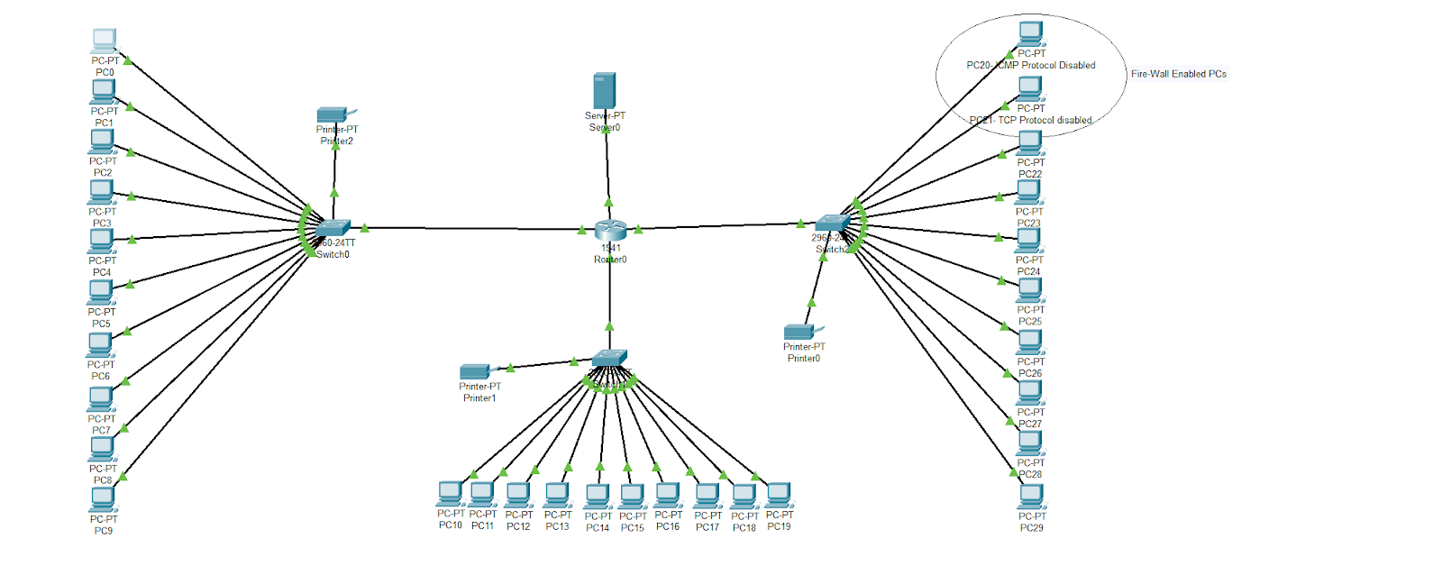

**FTP Demonstration**

**Step 1:** Creating a text file **“FTPfile1.txt”** in PC1.

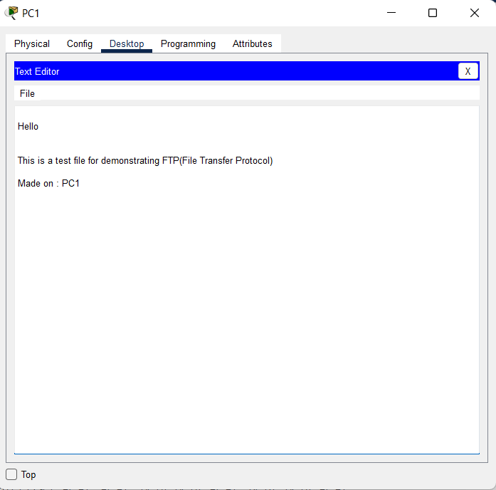

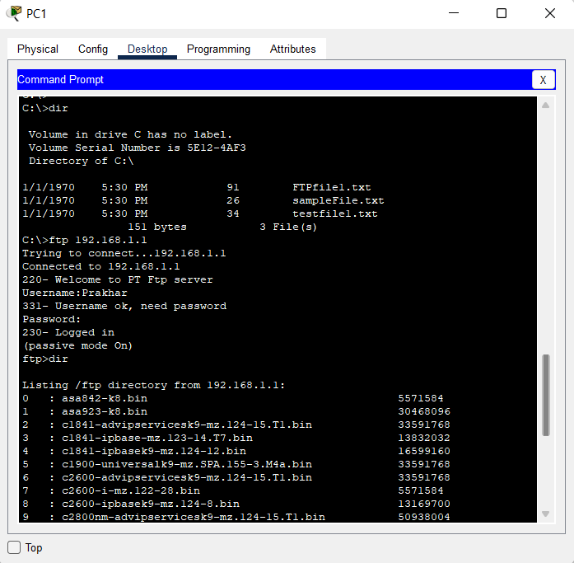

The file that we created, **“FTPfile1.txt”,** is in the directory of the PC1.

So, for making it available all over the network (Inter Café) we need to implement FTP (File Transfer Protocol) using the server.

For that, we will login into the server via > **ftp 192.168.1.1**

**192.168.1.1 –** server’s ip address.

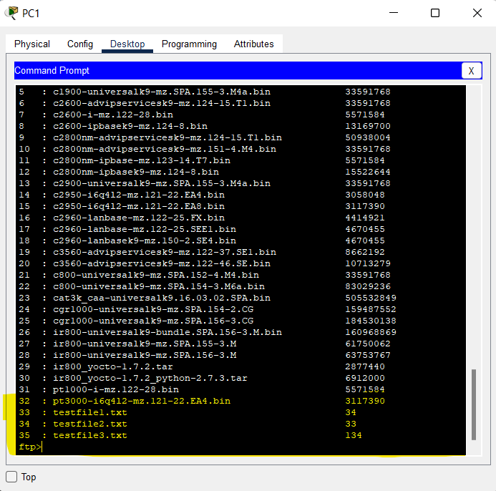

**Step 2:** After login is successful, we will check the directory of the server.There it does not have the file that we created (“FTPfile1.txt”) on PC1, yet.

So, we will upload it on the server.

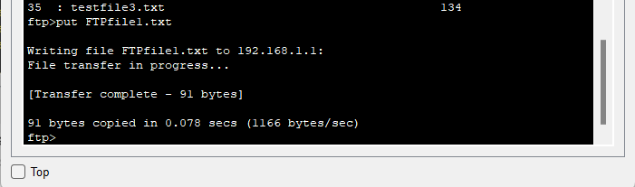

**Step 3:** Check the directory of the server again. Now, the “**FTPfile1.txt”** is available on the server directory.

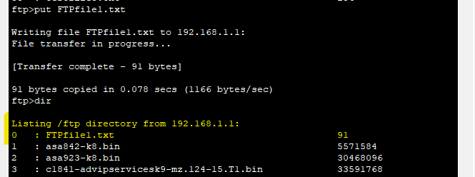

**Step 4:** After the file uploading is done, we disconnect from the server using **>quit**

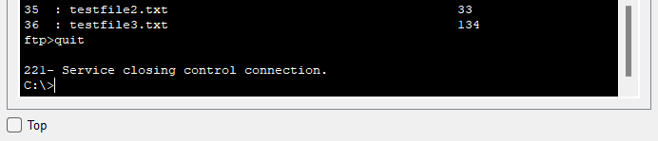

**Step 5:** We can go to any PC now to access the file “**FTPfile1.txt”**.

Say, we take PC-23. We checked the directory of PC-23, it did not contain the required file.

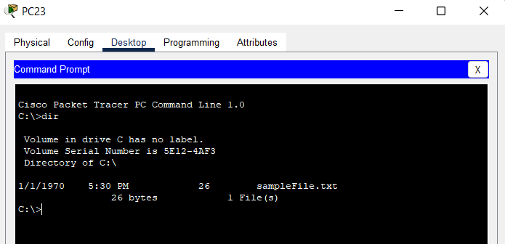

**Step 6**: So, we login to the server and get the required file on this PC-23 from there.

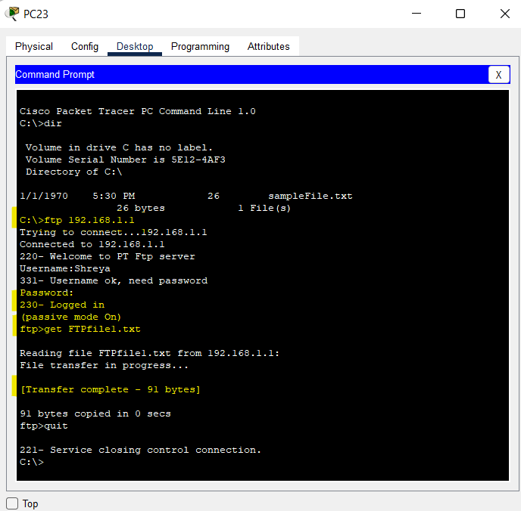

**Step 7:** Now the file (which was originally created on PC1) has been saved in PC-23, through FTP. Checking directory of PC-23.

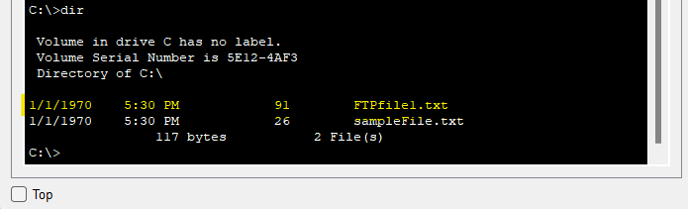

**Step 8:** We can open the file **“FTPfile1.txt”** on PC-23 through text editor.

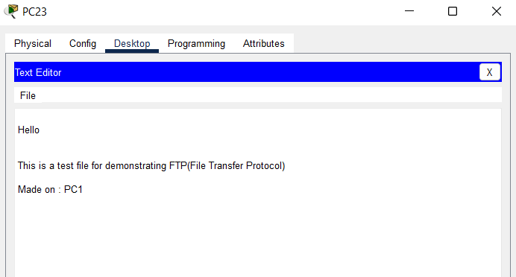

**Fire-Wall Implementation for web filtering**

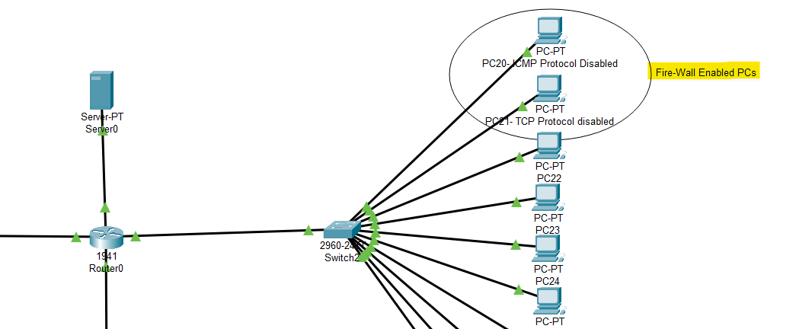

PC20 & PC21 are enabled with Fire wall: **Blocking the ICMP Protocol in PC-20** & **Blocking the TCP Protocol in PC-21**.

These PCs cannot be used to ping other PCs, the FTP won't work on them and the file transferring via loging in the server will be disabled.

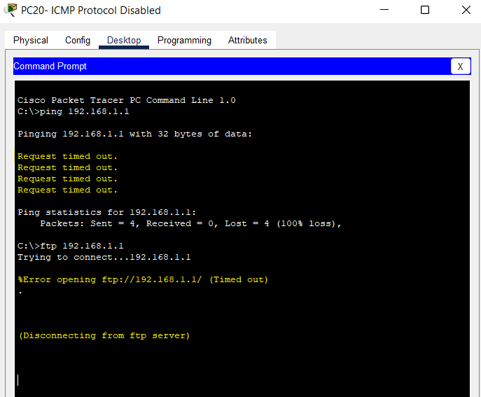

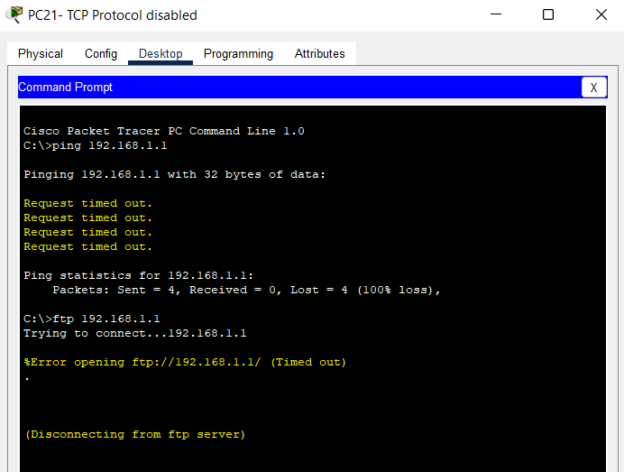

**Web Filtering is successfully implemented using firewall protocol disabling.**

**Calculations, Implementations and Result:**

**Calculations**

|  |  |  |  |
| --- | --- | --- | --- |
| Sr.No | Device | IP Address | Subnet Mask |
| 1. | PC0 | 192.168.1.40 | 255.255.255.0 |
| 2. | PC1 | 192.168.1.4 | 255.255.255.0 |
| 3. | PC2 | 192.168.1.44 | 255.255.255.0 |
| 4. | PC3 | 192.168.1.26 | 255.255.255.0 |
| 5. | PC4 | 192.168.1.22 | 255.255.255.0 |
| 6. | PC5 | 192.168.1.43 | 255.255.255.0 |
| 7. | PC6 | 192.168.1.17 | 255.255.255.0 |
| 8. | PC7 | 192.168.1.9 | 255.255.255.0 |
| 9. | PC8 | 192.168.1.34 | 255.255.255.0 |
| 10. | PC9 | 192.168.1.36 | 255.255.255.0 |
| 11. | PC10 | 192.168.1.27 | 255.255.255.0 |
| 12. | PC11 | 192.168.1.37 | 255.255.255.0 |
| 13. | PC12 | 192.168.1.10 | 255.255.255.0 |
| 14. | PC13 | 192.168.1.5 | 255.255.255.0 |
| 15. | PC14 | 192.168.1.35 | 255.255.255.0 |
| 16. | PC15 | 192.168.1.7 | 255.255.255.0 |
| 17. | PC16 | 192.168.1.14 | 255.255.255.0 |
| 18. | PC17 | 192.168.1.13 | 255.255.255.0 |
| 19. | PC18 | 192.168.1.21 | 255.255.255.0 |
| 20. | PC19 | 192.168.1.12 | 255.255.255.0 |
| 21. | **PC20** | **169.254.40.104** | **255.255.0.0** |
| 22. | **PC21** | **169.254.73.168** | **255.255.0.0** |
| 23. | PC22 | 192.168.1.18 | 255.255.255.0 |
| 24. | PC23 | 192.168.1.45 | 255.255.255.0 |
| 25. | PC24 | 192.168.1.8 | 255.255.255.0 |
| 26. | PC25 | 192.168.1.38 | 255.255.255.0 |
| 27. | PC26 | 192.168.1.6 | 255.255.255.0 |
| 28. | PC27 | 192.168.1.25 | 255.255.255.0 |
| 29. | PC28 | 192.168.1.13 | 255.255.255.0 |
| 30. | PC29 | 192.168.1.30 | 255.255.255.0 |
| 35. | **Server0** | **192.168.1.1** | **255.255.255.0** |

**Implementations**

* PC-20 and PC-21 have different IP addresses because they are restricted by firewall, filtering their access to other PCs and Server. Therefore, their Subnet mask is also different.
* The IP addresses of all the PCs are assigned using DHCP (Dynamic Host Configuration Protocol). So, every time the connection is reset, or the PCs are moved or reconfigured, the allocated IP addresses change to new dynamically allocated addresses.
* The **Server’s IP** Address remains constant throughout because it is defined in a static manner.
* A proper well-functioning Internet Café is implemented successfully which provides features like Firewall protection (Web Filtering), sharing of files from one PC to another via server (FTP demonstration), message passing and accessing the common printer between 10 PCs.
* This network design can be implemented in a broader scale too with additional features.
* The Network Design is a good proposal for implementation of Internet Café which supports a large number of users sitting and working at the same time.

**Results**

The Network Design for an Internet Café was successfully created and implemented.

**Inference from the Results:**

1. Successful implementation of Network Design for an Internet Café.
2. Design involves 30 PCs, 3 Switches, 1 router, 3 printers and 1 server.
3. PCs can share/access files amongst each other via the server using FTP protocol.
4. Out of 30 PCs, two PCs are restricted by firewall and thus they cannot implement certain inherent protocol functions.
5. There are three printers in total, out of which one printer each is assigned to a set of 10 PCs from a total of 30 PCs.
6. Messages can be sent from one device to another.
7. You can also check the connectivity between two devices or the device and the server using ping command.
8. Any PC can access the main server using admin credentials assigned to each user.
9. The internet café can accommodate up to 30 users working at a time using a single ASDL connection.

**References:**

1. CISCO Community, 2015, “Network Design Requirements” -

<https://community.cisco.com/legacyfs/online/ccde_9781587144615_chapter1.pdf>

1. Babasaheb Bhimrao Ambedkar University is a Central University, 2013, “Design Requirement Analysis” -

<https://www.bbau.ac.in/dept/dit/TM/Requirement%20Analysis.pdf>

1. Wikipedia, 2013, “Computer Network Diagram” -

<https://en.wikipedia.org/wiki/Computer_network_diagram>

1. Investopedia, 2012, “IP Address Design” -

<https://www.investopedia.com/terms/i/ip-address.asp#:~:text=in%20some%20instances.-,How%20an%20IP%20Address%20Works,private%2C%20static%2C%20and%20dynamic>.

1. Wikipedia, 2013, “ADSL Router” –

<https://en.wikipedia.org/wiki/Asymmetric_digital_subscriber_line>

1. Wikipedia, 2022, “Switch” –

<https://en.wikipedia.org/wiki/Network_switch>

1. Wikipedia, 2014, “Computers” -

<https://en.wikipedia.org/wiki/Node_(networking)>

1. Quora, 2017, “Operating Systems License” –

<https://www.quora.com/What-is-meant-by-a-licensed-OS>

1. Wikipedia, 2005, “Antivirus” –

<https://en.wikipedia.org/wiki/Antivirus_software>